'Programmer: Samantha Naini
'Exercise: Chapter 6 Programming Project 1
'Date: 4/15/2012
'Program Purpose: To calculate the amount of caffeine left in a person's body after coffee consumption.

Option Strict On
Option Explicit On

Public Class frmCaffeine

Private Sub btnCompute_Click(ByVal sender As System.Object, ByVal e As System.EventArgs) Handles btnCompute.Click

Dim Milligrams As Double = 130
Dim Hours As Double
Dim HourlyMilligrams As Double

'sub procedure to find out how many hours until 65mg remains:
SixtyFiveMgRemains(Hours, Milligrams)

'sub procedure to find out remaining quantity of mg after 24 hours (for one cup only):
OneCup24Hours(Hours, Milligrams)

'sub procedure to find out the mg left in system after 24 hours while consuming one whole cup per hour:
HourlyCups(Hours, HourlyMilligrams)

End Sub

Sub SixtyFiveMgRemains(ByRef Hours As Double, ByRef Milligrams As Double)

Do Until Milligrams <= 65
Milligrams = Milligrams - (Milligrams * 0.13)
Hours = Hours + 1
Loop

txt65mg.Text = CStr("" & Hours & " hours")
End Sub

Sub OneCup24Hours(ByRef Hours As Double, ByRef Milligrams As Double)

Do Until Hours = 24
Milligrams = Math.Round(Milligrams - (Milligrams * 0.13), 2)
Hours = Hours + 1
Loop

txtOneCup24h.Text = CStr("" & Milligrams & " mg")
End Sub

'*****I am having trouble with this last procedure; my result always amounts to 0mg*****

Sub HourlyCups(ByRef Hours As Double, ByRef HourlyMilligrams As Double)

Do Until Hours <= 24
HourlyMilligrams = HourlyMilligrams + (HourlyMilligrams - (HourlyMilligrams * 0.13))
Hours += 1
Loop

txtHrlyCup24h.Text = CStr("" & HourlyMilligrams & " mg")
End Sub

Private Sub btnClear_Click(ByVal sender As System.Object, ByVal e As System.EventArgs) Handles btnClear.Click
txt65mg.Clear()
txt65mg.Focus()
txtOneCup24h.Clear()
txtHrlyCup24h.Clear()
End Sub

Private Sub btnEnd_Click(ByVal sender As System.Object, ByVal e As System.EventArgs) Handles btnEnd.Click
If MsgBox("Do you really want to quit?", MsgBoxStyle.YesNoCancel, "End Program") = MsgBoxResult.Yes Then
MsgBox("Have a nice day!")
Me.Close()
End If
End Sub
End Class
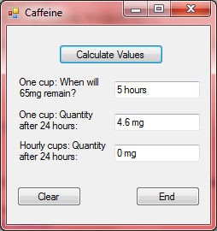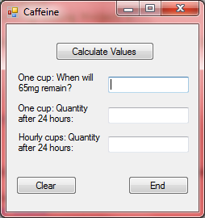←Clear button
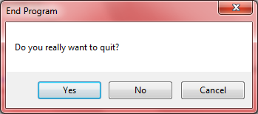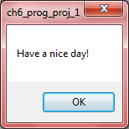←End button

